The Workshop Board is the student facing display of available stations and work available to them, or assigned by their teacher. The variety of models that can be implemented call for many different, easy to use displays that capture the essence of each type.
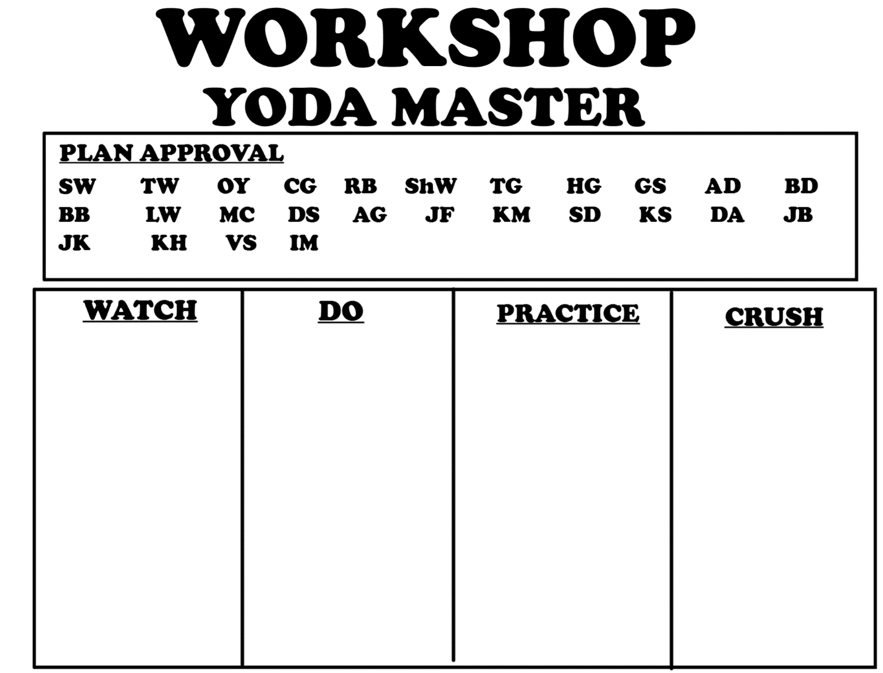
Workshop Board – Full Choice

This board is for the full choice model of Workshop, where students curate their own playlists to address missed objectives from earlier in the year. Students have to grapple with the countless sites and resources we have in the room to create a plan of action that will lead to success on a retake of that assessment. There are essentially 4 components to their plans watch (as in a video or teacher podcast), do (apply the skill to an activity), practice (find a way to practice the skill at a high level), crush (retake the assessment). The board is powerful not just as a reminder of the necessary ingredients to a great plan, but also as a way to remember where along the plan each kid is. For example, students must get their plan, complete with specific sites and resources, approved before continuing. They will then work through their plan to try and address the deficiency. If a student is on practice, then the next time this model of Workshop is implemented, the board will still be the same, saved from the previous day. This is powerful because it instills a branded continuum of learning to the students that they can carry with them to middle school.
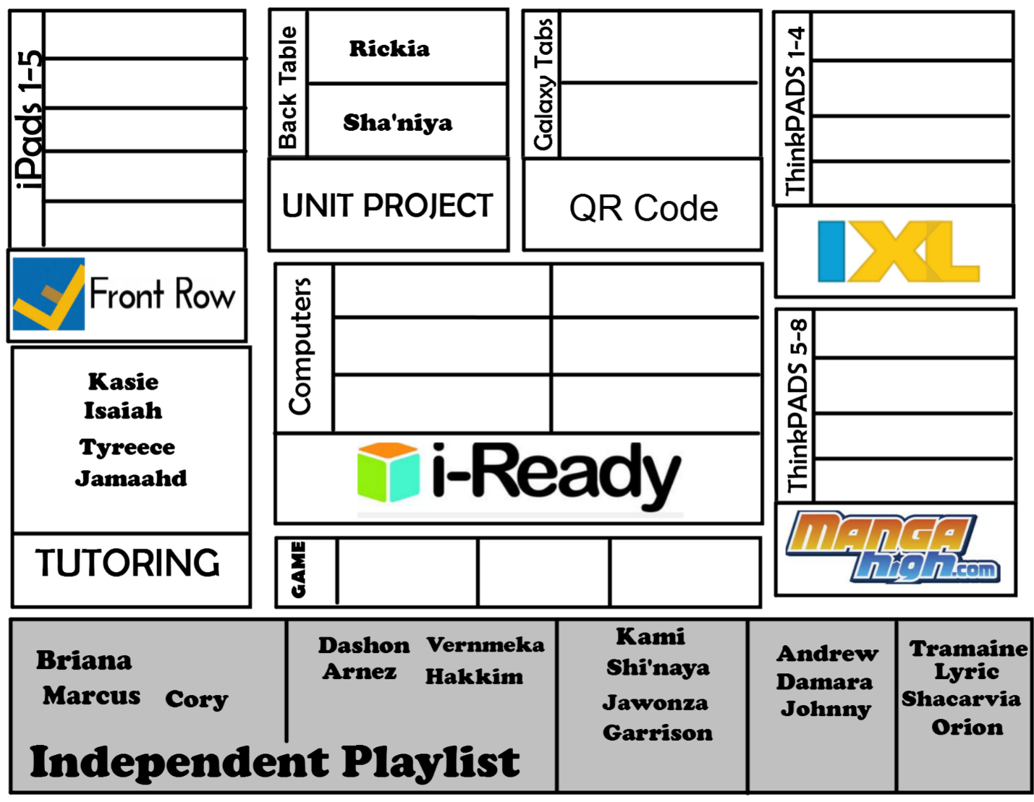
Workshop Board – Limited Choice Model

In this model, students are given choice over the specific activity that they will do. At each of these stations, there are a set of procedures that go along with them. For example, FrontRow is always on iPads because of the ease of the app. At each site or location, the program has need adapted to fit the students needs. Still, students will have to justify their selections as pertinent and worthwhile on their Reflect and Connect logs. Students might also leave their name in the “independent playlist” section. This is if a personalized playlist has been created and approved by the student to address a specific missed skill (refer to “Yoda Master” strategies). Notice that at times I will always reserve the right to place students at particular stations. This empowers students because they feel as if they have a “specific mission” to complete.

Workshop Board – The Grouped Model
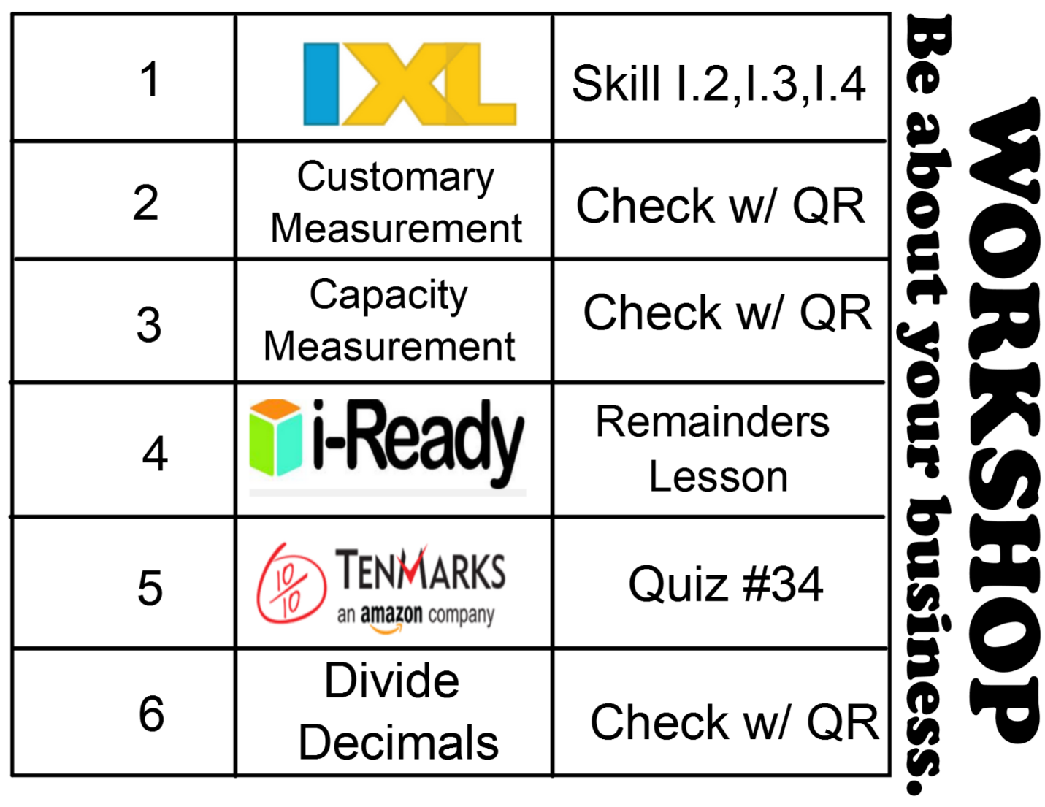

In this adaptation of Workshop, the students are grouped from formative assessments and work on a particular skill that was not mastered. While the majority of Workshop sessions are the choice model, this model provides a few key purposes. One, this model allows for group learning, whereas much of the choice model is independent. Many student learn best from their peers. Also, this model provides a way for me to encourage accurate students self-remediation when they get choice again. Students know that in the groups they are working on a skill they all missed. That camaraderie helps them focus on the task at hand. An essential component, then, of the group model is having students check their progress. This makes it ideal to work with questions with a QR code answer or in check as you go programs like IXL. Students are in a grouped model at least once a week, and expected to address the missing skills in their plans for future rotations.

