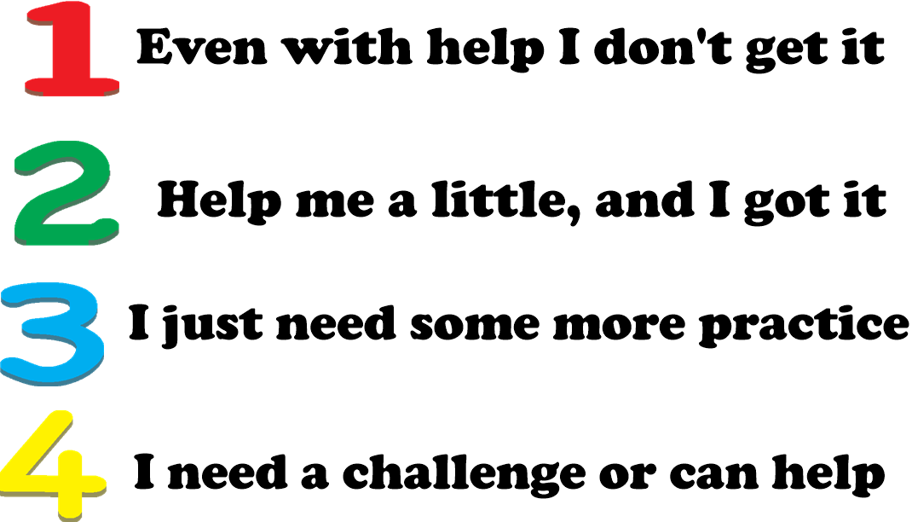
MARZANO’s SELF ASSESSMENT LEVELS

Students hold up a number after a particular lesson skill to see where they stand. It helps to guide their thinking by relating it to the skill. For example, “Level 3’s you might be getting most of your questions right but still a few mistakes” or “Level 2’s you might still be forgetting to do either multiplication or division in the order of operations based on which comes first”.
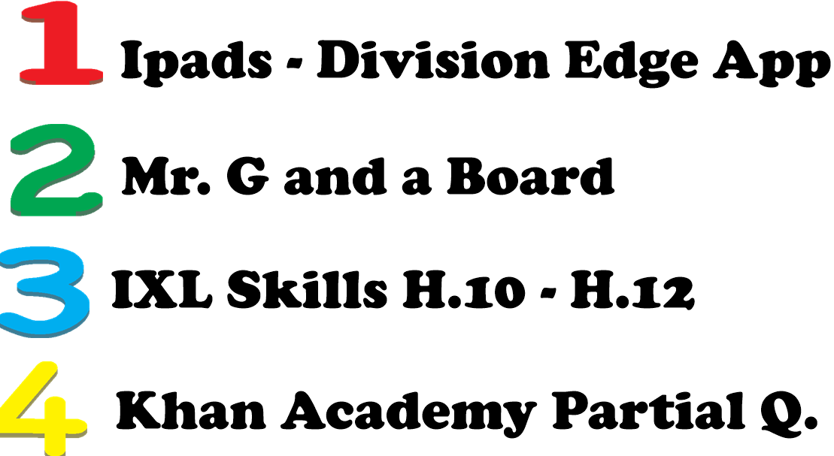
SAMPLE INDEPENDENT PRACTICE FOR DIFFERENT LEVELS

