Enrichment Academy descriptions – Pleasant View School
March 11 – June 10, 2016 -- Grades K – 1

SM-ART Superheroes Unite!

Do you love art? Do you love Superheroes? Have you ever wanted to design your own Superhero costume or create your own logo? Well, Pleasant View is looking for a few good panthers to help Serve & Protect our school. We will use art to explore Superheroes, and practice being kind to one another as Superheroes do. If you’re interested, sign up for Sm-ART Heroes!

Architects in Action

Are you creative? Do you like to use your imagination and design? If so, grab your blue prints and join Architects in Action! We will be sketching our ideas and creating real life models of buildings, bridges, castles and caves. Bring your technique and enthusiasm -- we have the tools, including popsicle-sticks, paint brushes, blocks piled high, sugar cubes, and clay … your limit is the sky! If you want to create, have fun, and be part of a construction crew, Architects in Action is the enrichment academy for you!

Ballet Brigade

Do you like to dance? Are you ready to explore the wonders of ballet? If so, it’s time to sign up to be a member of the Ballet Brigade! Boys and girls will investigate the early stages of ballet, and develop skills for bar work and combinations. Ballet is not for the faint of heart – come embrace discipline and dance in a way that builds your strength and character.

Kids in Action 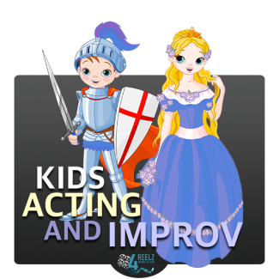
Do you like music? Do you like to sing? Do you like to act? We will sing, act and create many things to incorporate your language, speaking and comprehension skills. It will be fun to do all this through music, art, and drama!
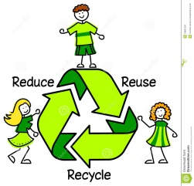 Panther PRIDE comes alive
Do you like to explore the wonders of nature? In this academy, come investigate the importance of recycling, sustainability, and the joys of outdoor recreation. Enjoy time spent in the outdoors with an eye towards increasing your interest and experience in crafts, collaboration, leadership, literacy, dexterity, and student-driven productivity.
Rainforest Friends 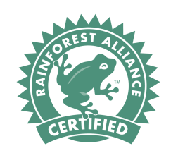
Do you want to learn all about the Rainforest? We will read The Great Kapok Tree by Lynne Cherry. We will learn why Rainforests are so important and why they are being destroyed. In addition to reading the book we will be doing a Reader’s Theater, doing Rainforest Math, creating beautiful art projects, doing a research project, and much, much more!

Strike a Pose – YOGA

If you like YOGA or want to try it – this is the academy for you! We will work on increasing our focusing abilities through body awareness and balance, breathing activities, and composition activities, such as journaling, and creating posters. Come strike a pose, and become calm, cool, and connected through the art of yoga.
Enrichment Academy descriptions – Pleasant View School
March 11 – June 10, 2016 -- Grades 2 – 3

Bake the World a Better Place
Calling all culinary masters! Do you have a passion for baking? Would you like to use that passion to help your community? Then this is the academy for you! You will not only be baking, but discovering different charitable organizations, and how they help others. You will research to find a worthy cause that you believe in. Then you will have to persuade others to join your cause. One charity a month will be chosen to receive the proceeds from our bake sale. How will you bake the world a better place!
Book Explorers
Do you love to read? Do you enjoy exploring books? Are you curious about authors and why they write? Do you find yourself making connections between books and the real world? If so, this is the academy for you! We will explore awesome books by world famous authors and illustrators. We may choose to explore one for a long time or switch books every week. In our academy, we will bring books to life, and you will engage in interactive read-alouds. We will also create cool crafts that relate to our chosen books. Come be a book explorer!

Enrichment Academy descriptions – Pleasant View School
March 11 – June 10, 2016 -- Grades 2 – 3

Building Friendships
Do you enjoy creating things? Come explore a world of building and creating for our preschool friends. We will design. We will invent. We will create. We will have fun. Some of our products may include felt board activities, science experiments, and math games. We will create posters to advertise and set up a schedule for preschoolers to come visit, play, and build friendships.

Helping Hands: Sign Language

Did you know that speaking is not the only way that you can communicate? Sign language is a language that was created in order for hearing-impaired persons to talk to one another without using spoken words. In this academy, we will be exposed to the American Sign Language alphabet, choose name signs, explore other important signs, and even choreograph signs to music! Sign language is a neat way to communicate with others, with friends, and with hearing-impaired individuals. So, if you'd like to learn a new language where you use your hands and body to express yourself, please join this academy. We look forward to signing with friends!

** If you are a 3rd grader in CHORUS, please indicate this on the Enrichment Academy sign-up sheet.**

Enrichment Academy descriptions – Pleasant View School
March 11 – June 10, 2016 -- Grades 2 – 4 ONLY

Junior City Year
It's never too early to be a leader! If you want to work closely with City Year and increase Panther PRIDE throughout our school, you should join this academy! As a City Year Junior corps member, you will discover different ways to be a leader, and engage in fun and interactive service projects around Pleasant View. If you are ready to serve – sign up: City Year needs YOUR help!
Swimming for FUN & FITNESS
Are you an avid swimmer? Do you want to practice, and improve your swimming skills? Our academy is designed for PV students to improve their overall swimming skill levels while having fun doing it! We will chart our more accomplished swimmers virtual ocean-like progress, and help our novice swimmers improve through fun games and activities.
Yoga, Pilates, and Zumba! Oh My!
Do you like dancing to upbeat music? Are you curious about learning more about yoga? If so, this academy is a perfect fit for you! Together we will learn the importance of staying active, being positive, and developing self-confidence while also having fun! We will learn energetic dance moves, as well as relaxing Yoga and Pilates’ poses.
** If you are a 3rd or 4th grader in CHORUS or CHANCE to DANCE, please indicate this on the Enrichment Academy sign-up sheet as your ONLY choice.**
Enrichment Academy descriptions – Pleasant View School
March 11 – June 10, 2016 -- Grades 3 – 5 ONLY

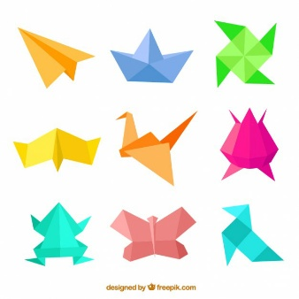 Origami Academy
Would you like to learn a new skill? How about making fun and beautiful works of art simply by folding a piece of paper? Come learn the ancient art of paper-folding known as origami. A piece of paper plus a bit of geometry can equal a whole new world of creativity. We will explore different styles of origami including modular origami in which different pieces are folded and assembled to create a final product as well as more traditional forms in which a single piece of paper can be transformed into a work of art. We will learn how to make fun, beautiful, and even amazing things from a simple sheet of paper. At the same time will we learn about the history of this very old art form and how many people still practice origami all over the world today! Being successful in origami will require care and precision, but anyone can master it. Sign up now!

PV PRIDE School CHORUS
Do you love to sing? Do you want to be a part of something bigger than yourself? Would you like to grow your talents and show your school pride? Singing is a passion and a creative outlet that enables you to grow self-confidence and find your voice. If you love to sing or want to give it a try, join our chorus to develop your singing skills and improve your range, and show your panther PRIDE.

Enrichment Academy descriptions – Pleasant View School
March 11 – June 10, 2016 -- Grades 3 – 5 ONLY

TEACH your TEACHER
Are you tired of the way you do schoolwork? Do you know another way to teach what your teacher is teaching? Would you rather use a different method to complete your work than the typical paper and pencil? Do you have a creative side? Are computer programs interesting to you? Do you like exploring different apps?
If you answered yes to most of these questions, then this academy is for you! Explore different apps and programs that will allow you and your teachers to complete assignments in interesting and innovative ways. Spend time researching a wide range of apps and programs to discover their purpose and evaluate their effectiveness. If you decide it’s a useful tool through your research and investigation -- use it, and create a how-to presentation on it to share your new found knowledge.
Will It Pinterest?

Are you always looking for a new idea? Are you curious and creative? In this academy, we will become scientists and explore the wide world of Pinterest. We will test of popular pins and see if they are a fail or reach the holy-grail. You will research experiments to hypothesize, and create living journals of your findings. Come along with me in this enrichment academy that asks the 21st century question: WILL IT PINTEREST?

** If you are a 3rd; 4th or 5th grader in CHANCE to DANCE or CHORUS, please indicate this on the Enrichment Academy sign-up sheet as your ONLY choice.**
Enrichment Academy descriptions – Pleasant View School
March 11 – June 10, 2016 -- Grades 4 – 5 ONLY

Chance to Dance 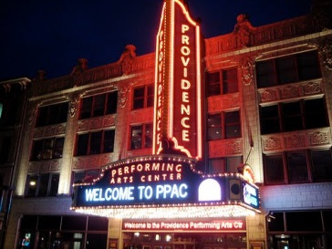
** If you are a 4th or 5th grader in CHANCE to Dance please indicate this as choice #1 on your Enrichment Academy sign-up sheet.**

Crack the Code
Have you ever wondered how computer programs or video games work? Join this academy to discover how to create computer code. We will solve coding problems and tell the computer what to do together before you launch off on your own to create your own code. Become a computer programmer, and find ways to teach your teachers how the world of gaming works.
Take it from the experts …
“Computers are going to be a big part of our future … and that future is yours to shape.” ~President Barack Obama
“Learning to write programs stretches your mind, and you think better …”~Bill Gates, Chairman, Microsoft
“… Let's get the whole world coding!” Eric Schmidt, Executive Chairman, Google
“In fifteen years we’ll be teaching programming just like reading and writing … and wondering why we didn’t do it sooner.” ~Mark Zuckerberg, Founder, Facebook
If you want to make our world smaller, and our future brighter, join us to learn analytical and problem solving skills through coding. Videos to watch for inspiration:
https://www.youtube.com/watch?v=nKIu9yen5nc&feature=youtu.be
https://www.youtube.com/watch?v=8sthaV8ddJ4&feature=youtu.be
Enrichment Academy descriptions – Pleasant View School
March 11 – June 10, 2016 -- Grades 4 – 5 ONLY

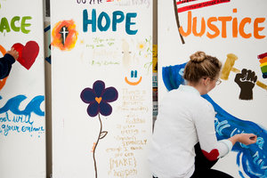 PV Change Agents & Ambassadors
Are you a leader? Would you like to make a difference in your school community as a change agent? Are you interested in making the world a better place through activism and action? If so, you should join forces to make positive change as a PV Change Agent & Ambassador. Come serve and lead at your school with PRIDE! Leave your mark.

Writer’s Workshop 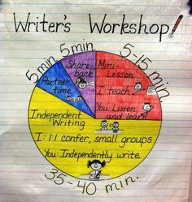
Do you like to write stories about mystery, sci-fi, and adventure? Do you like to create poetry that captures the essence of the world around you? If yes is your answer, then our PV Writer's Workshop is the place for you! In this academy we will read short stories and poetry created by famous writers and poets as a means of inspiration for our own writing. We will craft stories of fiction and non-fiction, and learn about different styles of poetry and create our own poems. Once we create our works, we will discover how to become skilled editors and edit one another pieces so that they are publication-ready. Our culminating project may be a book that contains your best work to share with the Pleasant View community or a project that showcases what we’ve created in cool and meaningful ways!

** If you are a 4th or 5th grader in CHANCE to DANCE or CHORUS, please indicate this on the Enrichment Academy sign-up sheet as your ONLY choice.**

