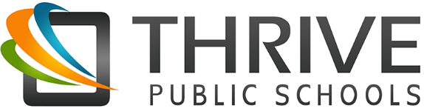
Blended Learning

Blended Learning is an education program in which a student learns: (1) at least in part through online learning, with some element of student control over time, place, path, and/or pace; (2) at least in part in a supervised brick-and-mortar location away from home; (3) and the modalities along each student’s learning path within a course or subject are connected to provide an integrated learning experience. Some resources to learn more:
- http://www.christenseninstitute.org/blended-learning-definitions-and-models/#sthash.mqbORuaj.dpuf
- https://www.khanacademy.org/partner-content/ssf-cci/sscc-intro-blended-learning/sscc-overview-blended-learning/v/sscc-blended-thecase

Blended Learning at Thrive

- Students have ownership of their learning and move at their own pace towards mastery of literacy and numeracy.

- To personalize learning, connections between online and offline learning are transparent (kids know what they are working on) and intentional (teachers are thoughtful in supporting and creating learning pathways).

- Opportunities for self-direction, reflection, and choice are built into the day.

- Data is used to guide learning paths & teaching practices

- Through multiple modalities students practice and achieve mastery of content knowledge and ways of being.

- Space is inviting & designed to be learner centered to foster both collaborative and independent learning.

- Dynamic groupings maximize student and teacher time in flexible ways

- Thoughtfully integrating multiple learning tools throughout our day (ie. technology)

- Teachers and students build strong relationships to create a joyful learning community where each child is heard, seen, & valued.

- High quality teachers act as facilitators, interveners, and mentors in order to personalize learning.

